Activity 1.  Write a description suggested by this image. | Activity 2.  Write a description suggested by this image.  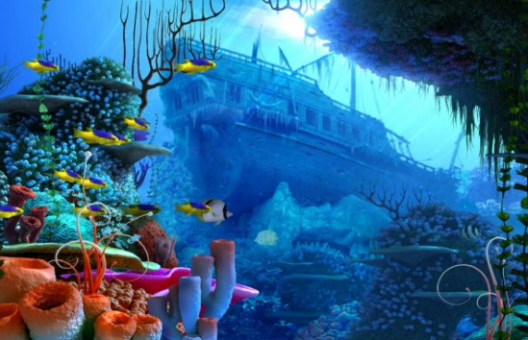 | Activity 3.  “It’s amazing what can happen when friends go camping...”  Write a short story to tell us what happened!  - Ambitious adjectives  - Humorous events  - Exciting verbs and adverbs | Activity 4.  “Slowly opening my eyes, I saw something…”  Write a short story that starts with this sentence.  - First person narrative  - Build tension and suspense  - Gothic motifs and themes
Activity 5.  “Young people are too often and too easily blamed for everything that is wrong with society today”  Write an article for a newspaper to explain your point of view. | Activity 6.  “Vain and superficial, fashion is a greedy industry that brings out the worst in people.”  Write an article for a school magazine to explain your point of view. | Activity 7.  “School Uniform stifles individuality and should be scrapped.”  Write the text of a speech for an assembly to your peers in which you explain your point of view. | Activity 8.  “When things are back to normal, climate change should be the number one priority for government.”  Write the text of a speech for your tutor group in which you explain your point of view.
Activity 9.  “Travelling abroad is damaging the environment. We should holiday in the UK more.”  Write a letter to your local newspaper giving your opinion. | Activity 10.  “Fireworks are dangerous and should be banned.”  Write a letter to your council offering your opinion on this statement. | Activity 1.  How does the writer use language to create a peaceful setting in this extract? (extract – Of Mice and Men)  • Use full sentences.  • Aim for 3 paragraphs  • Use clear quotes  • Subject terminology  • Explain the effect | Activity 12.  How does the writer use language to present the family relationships in this extract? (extract – Hunger Games)  • Use full sentences.  • Aim for 3 paragraphs  • Use clear quotes  • Subject terminology  • Explain the effect

Activity 13.  Write a review of a novel you’ve read this year: e.g. Cirque du Freak.  Include specific, accurate information, with correct English. You could include images and/or quotes. Have a look at a book review online for some inspiration! | Activity 14.  Write a review of a film you’ve seen this year.  What did you like about it? What didn’t you like? What characters were in it? Did the plot keep you gripped? Was it too long? What about the acting? The jokes? The action? Most importantly, should people go to see it? Why? | Activity 15.  How does the writer structure the text to develop the setting? (Of Mice and Men extract)  • Aim for 3 paragraphs  • Use clear quotes  • Subject terminology  • Explain the effect.  Consider punctuation, repetition, tension, sentence lengths | Activity 16.  How does the writer structure the text to interest the reader? (Hunger Games extract)  • Aim for 3 paragraphs  • Use clear quotes  • Subject terminology  • Explain the effect.  Consider punctuation, repetition, tension, sentence lengths
Activity 17.  Create a Facebook profile for your favourite fictional character from a book.  Remember to include factual information (D.O.B, education, hometown) and also status updates of what they're thinking. | Activity 18.  Create your own superhero and write a short story with them in it.  Finished? Draw a comic strip of what happened in your story. | Activity 19.  Write a description suggested by this image. | Activity 20.  Write a description suggested by this image.  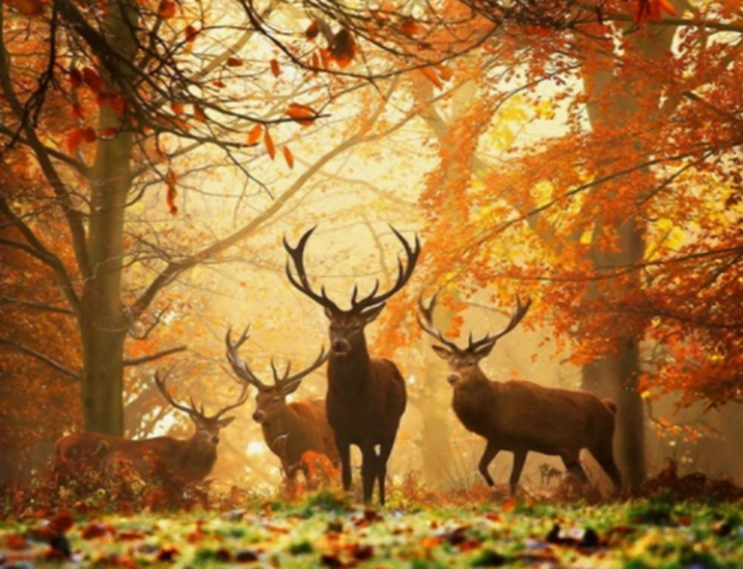
Activity 21.  “I woke up to the smell of burning.”  Write the opening of a story about this man.  - Start in the middle  - Use personification  - First person narrative | Activity 22.  “The school basement was strictly off-limits. Rules are meant to be broken.”  Tell this story.  - Third person narrative  - Build tension and suspense  - Include sensory details | Activity 23.  Read the information on the next page about Norse mythology, and choose a god or goddess that you would like to research.  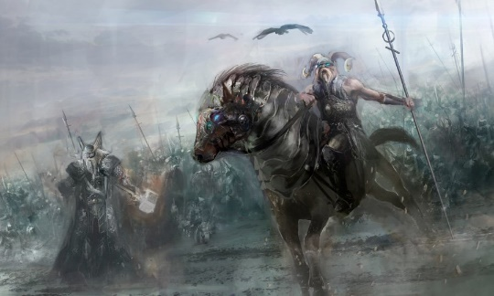  Produce a detailed, interesting,  imaginative fact file about your  chosen character.

The Big Summer Project! – Read the information below about Norse mythology
The Gods of Norse Mythology  The Norse peoples were from Scandinavia. They spread their beliefs throughout Europe during the Viking Age. They believed in nine worlds (such as Asgard, where the gods lived, Alfheim, where the elves lived, and Midgard, or Earth). They believed that the nine worlds were connected by the branches of a great tree called Yggdrasil, and a rainbow bridge called the Bifrost. They also believed in many gods and goddesses. These included:  Odin was the supreme deity of Norse mythology and the greatest among the Norse gods was Odin. He was the awe-inspiring ruler of Asgard, and the god of war, poetry and magic.  Thor was Odin’s son. He was the protector of humanity and the powerful god of thunder who wielded a hammer named Mjöllnir. He was known for his bravery and strength.  Freya was another goddess of love, but also war and battle. She was the courageous warrior leader of the Valkyrie. She was the sister of Freyr.  Loki was a mischievous god who could shape-shift and can take up animalistic forms. He was often a friend to the gods – as well as their enemies.  Freyr was the god of fertility and one of the most respected gods of the Vanir clan. Freyr was a symbol of prosperity and good weather.  Frigg was Odin’s wife, and a goddess of beauty, love and fate. She was the mighty queen of Asgard, who was gifted with the power of prophecy, and yet, was surrounded by secrecy.  Balder was a son of Frigg and Odin. He was described as living between heaven and earth. Balder was the god of beauty, kindness and fairness.  Tyr was a brave, heroic god of war, but also law and justice. He was one of the wisest gods, who fought to keep Asgard safe from evil.  Other important gods and goddesses included Hela (goddess of death), Heimdall (the gatekeeper of the Bifrost), Idunna (goddess of youth and beauty) and Njord (god of the sea). | Your challenge:  Using your fact-file produced for the Research Challenge (Activity 23), plan and write a creative, ambitious and exciting new mythological story featuring your chosen god or goddess.  This story should be a detailed narrative and at least 3-4 pages of best work.  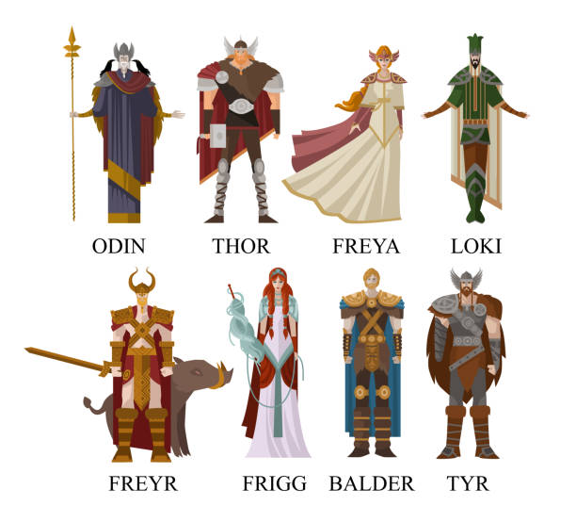  Get it ready over the summer break to present to your English teacher in September!

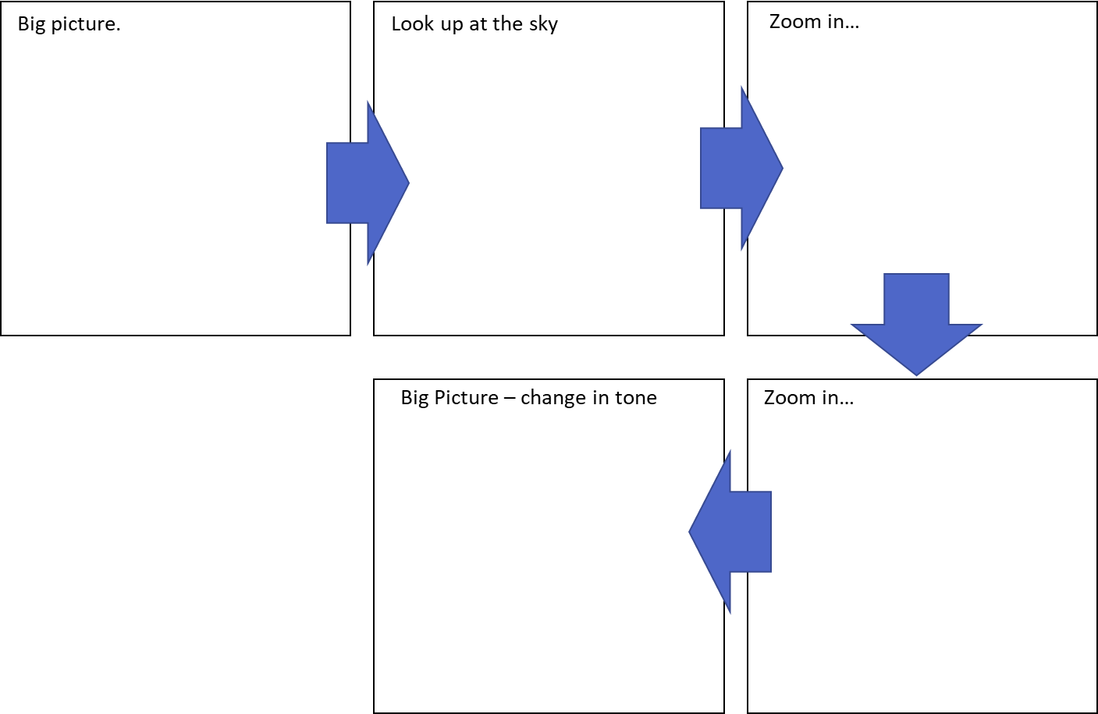
Writing to describe structure.
Extract from Of Mice and Men by John Steinbeck (1937)
A few miles south of Soledad, the Salinas River drops in close to the hillside bank and runs deep and green. The water is warm too, for it has slipped twinkling over the yellow sands in the sunlight before reaching the narrow pool. On one side of the river the golden foothill slopes curve up to the strong and rocky Gabilan mountains, but on the valley side the water is lined with trees—willows fresh and green with every spring, carrying in their lower leaf junctures the debris of the winter’s flooding; and sycamores with mottled, white, recumbent limbs and branches that arch over the pool. On the sandy bank under the trees the leaves lie deep and so crisp that a lizard makes a great skittering if he runs among them. Rabbits come out of the brush to sit on the sand in the evening, and the damp flats are covered with the night tracks of ’coons, and with the spread pads of dogs from the ranches, and with the split-wedge tracks of deer that come to drink in the dark.

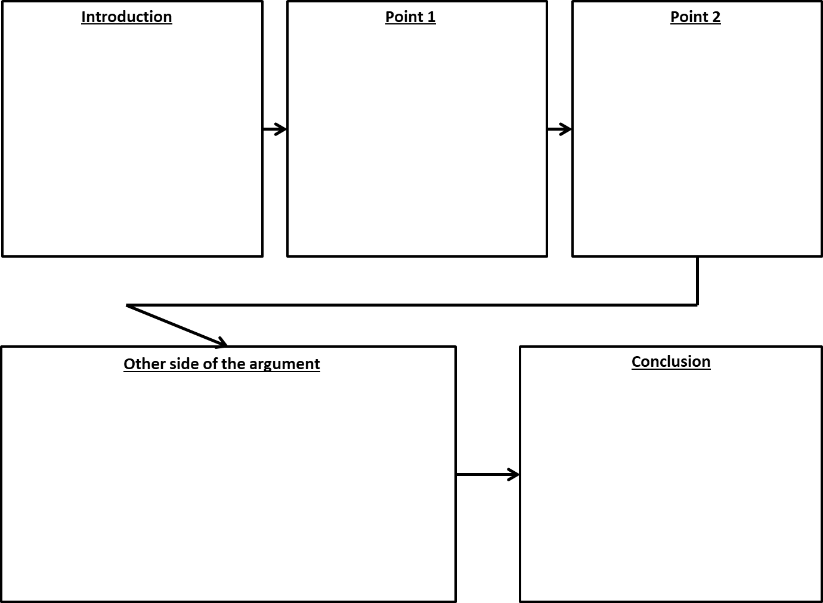
Critical analysis writing structure.
Extract from The Hunger Games by Suzanne Collins (2008)
When I wake up, the other side of the bed is cold. My fingers stretch out, seeking Prim’s warmth but finding only the rough canvas cover of the mattress. She must have had bad dreams and climbed in with our mother. Of course she did. This is the day of the reaping. I prop myself up on one elbow. There’s enough light in the bedroom to see them. My little sister, Prim, curled up on her side, cocooned in my mother’s body, their cheeks pressed together. In sleep, my mother looks younger, still worn but not so beaten-down. Prim’s face is as fresh as a raindrop, as lovely as the primrose for which she was named. My mother was very beautiful once, too. Or so they tell me. Sitting at Prim’s knees, guarding her, is the world’s ugliest cat. Mashed-in nose, half of one ear missing, eyes the colour of rotting squash. Prim named him Buttercup, insisting that his muddy yellow coat matched the bright flower. He hates me. Or at least distrusts me.

